Essential Questions for “The Cask of Amontillado”
- Pre-Vocabulary:
Amontillado:

Retribution:

Impunity:

- Is revenge ever justified? Why or Why not?
- What is suspense, and how is it used in storytelling?
- Examples of Hyperbole
- Examples of Metaphor
- Examples of Foreshadowing
- Examples of Irony

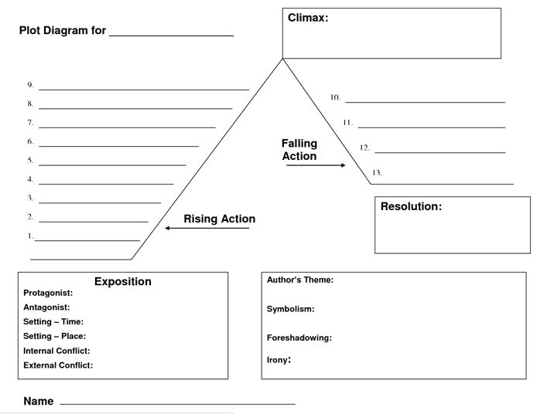
- Plot Diagram - Add details from the story for Exposition, Conflict, Rising Action, Climax, Falling Action, Resolution

