ASSESSMENT  MASTER 168 | Assessment for Unit 3 (Student Version)

Part I—Multiple Choice

Use the statements of the following speakers to answer Questions 1, 2, 3.

- Speaker 1: “Westerners do not respect us for adopting their styles, they laugh at us. What we need to do in Japan is to stop this mad rush to become just like the West; we need to look closely at what the West has to offer, then take the best features and adapt them to our Japanese ways.”

Speaker 2: “The Shogun must remain strong in order to ensure that harmony, security and respect for tradition continue in Japan as they always have. The Exclusion Laws will guarantee the protection of Japanese culture from foreign contamination.

Speaker 3: “The compulsory seclusion of the Japanese is a wrong, not only to themselves but to the civilized world…The Japanese undoubtedly have an exclusive right to the possession of their territory; but they must not abuse that right to the extent of the barring of all other nations from a participation in its riches and virtues.”

Speaker 4: “We have no choice but to Westernize. If we do not build our industrial and military strength quickly there is a good chance that Japan will end in the same state as China. We must, in a sense, beat the West at the West’s own game.”

- Which question best describes the issue being addressed by all the speakers?

- Should the West be given control of Japan?
- How should the leaders of Japan ensure that they have the power they need to govern Japan?
- To what extent should Japan adopt a policy of imperialism?
- How should Japan respond to contact with influences from outside its borders?

- In which of the following choices is one of the above speakers correctly identified?

- Speaker 1— a Japanese supporter of Western democratic government
- Speaker 2 – a supporter of the traditions of Edo Japan
- Speaker 3 – an American opponent of trade with Japan
- Speaker 4 – a member of the conservative backlash to changes in Meiji Japan

- Which Speakers express opinions which are most similar?

- Speakers 1 and 2
- Speakers 1 and 3
- Speakers 2 and 3
- Speakers 3 and 4

Use the following map to answer Question 4.
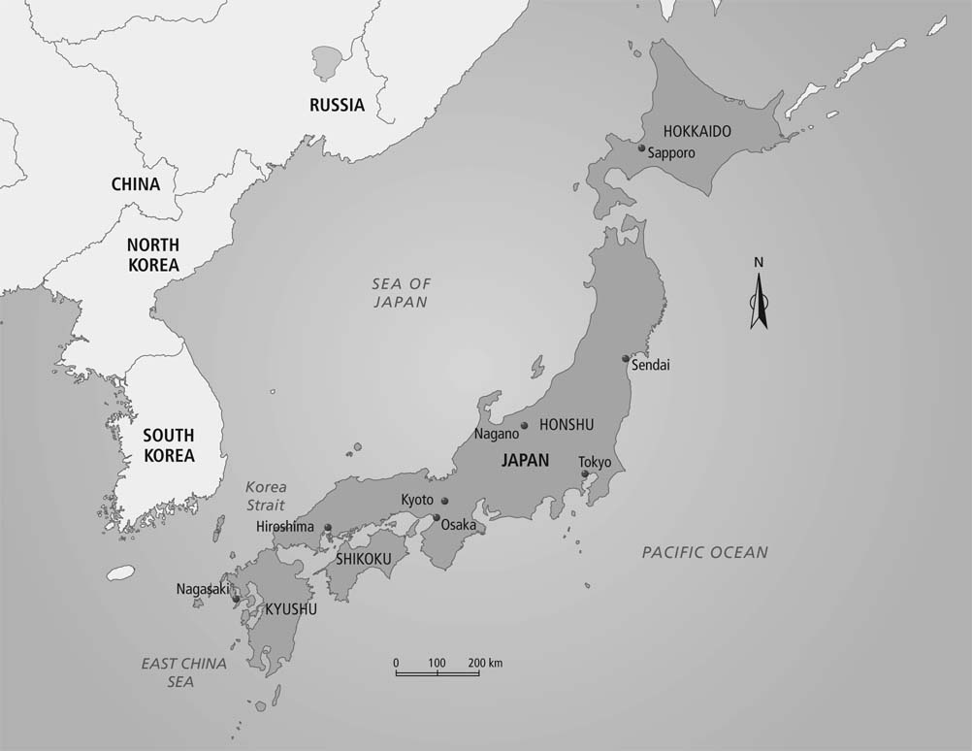

- Using the map above, which statement about Japan is incorrect?

- Japan is more than 1000 km from the nearest country.
- Japan and three other nations border the Sea of Japan.
- Koreans are the closest neighbours to the Japanese.
- The bulk of Japan’s population is on the island of Honshu.

- Which of the following features was originally a Japanese creation or idea, and was not adapted by the Japanese from other cultures?

- The use of characters for writing
- The principles of Confucianism
- The floating world of the arts and culture
- The cannon used in the Russo-Japanese War

- The samurai, the daimyo and the shogun all share the common experience of

- loss of social status after the end of Edo Japan
- increase in political power during the Meiji Restoration
- decrease in economic wealth during the Edo period
- gain in social influence during the Meiji Restoration

Use the following descriptions to answer Question 7.

Description A: The Exclusion Laws which helped to create the isolation of Edo Japan were designed to expel all foreigners from Japan, along with their cultural and religious ideas. The aim was to cut off contact between Japan and the outside world.

Description B: The Unequal Treaties opened Japanese ports to trade with Western nations, guaranteed that Japan would supply coal to foreign ships and included the promise that any privilege or agreement that Japan made with any other nation would automatically be given to the United States as well.

- Which of the following statements about the descriptions is correct?

- Both the descriptions are true.
- Both the descriptions are false.
- Description A is true, but description B is false
- Description B is true, but description A is false

- In Japan, the immediate response to the signing of the Unequal Treaties was

- an increase in support for the Shogun
- the onset of civil war and disorder
- the end of Japanese independence
- a decrease in trade and industry

- Which of the following characteristics of Japan was most useful in Japanese westernization?

- Japan’s isolated location in the world
- The limited amount of arable land in Japan promoted efficient agriculture
- The religious traditions of the Japanese encouraged change
- Japan’s practice of borrowing and adapting from other cultures

- Three of the following statements about the Ainu people of Japan describe aspects of their history and culture which are similar to the history of the First Nations people of Canada. Choose the statement that is the exception.

- Gods for each group were often associated with features of the physical world, such as fire, water, wind or animals.
- Members of each group were pushed off much of their land by settlers and were often restricted to living in specific areas.
- Each group has agreed with its government on the first steps toward more self-government.
- Attempts were made by each government to assimilate the indigenous people, by getting rid of their language, customs and dress.

- In which of the following choices dealing with Japanese history is a cause correctly paired with a result which followed?
Cause | Result
- The Japanese Shogun felt threatened by the increase in Christianity and foreign influence in Japan. | - The Unequal Treaties are signed by the Japanese and Western nations.
- Commodore Perry arrives in Japan demanding trading arrangements with the Japanese government. | - The Exclusion Laws are passed in Japan to close access to the island.
- The Meiji Restoration aims at reestablishing the strong, central government, led by the Emperor. | - The daimyo and the samurai are stripped of their local political and taxation duties.
- d. Japanese military forces capture Korea after a war with Russia. | - Japanese Westernization aims to create a Japan capable of competing with the West.

Use the following quotation to answer Questions 12 and 13.
We recognize the excellence of Western civilization. We value the Western theories of rights, liberty and equality; and we respect Western philosophy and morals….Above all, we esteem Western science, economics and industry. These, however, ought not to be adopted simply because they are Western; they ought to be adopted only if they can contribute to Japan’s welfare.

- The writer of the quotation, taken from a Japanese newspaper in 1889, was most likely a supporter of

- Japanese isolationism from outside influences
- Westernization of Japanese culture and industry
- Japanese borrowing of Western economic and political ideas
- Democratization of the Japanese political system

- The writer of this quotation and people who hold the same belief would have seen the early actions of the Meiji Restoration as

- acceptable, because they led to industrial growth in Japan
- acceptable, because Japan’s government was made to resemble that of the United States
- unacceptable, because Japanese traditions were followed too closely
- unacceptable, because Japanese traditions were often ignored in implementing foreign practices

- The Japanese creation of terraces for crops, use of silkworms for clothing material and harvesting of seaweed and soybeans would all be most useful in explaining how, during the Edo period, Japan was

- able to exist self-sufficiently
- capable of feeding a large population
- dependant upon foreign trade
- reliant upon industrial production

- Which of the following statements correctly describes the changing role of the Emperor in the history of Japan?

- The Emperor and the Shogun were seen as gods, but with the end of the shogunate, only the Emperor ran the government of Japan.
- The Emperor of Japan has always been seen as having god-like status, but his actual role in daily government has been small.
- In Edo Japan, the Emperor controlled the daily government of Japan, while the Shogun was seen as a distant figurehead.
- In Meiji Japan, the role of the Emperor was reduced from the position that he had held during the Edo period.
- The story of the 47 ronin is most used to illustrate the importance in Japanese culture of the values of

- military service and obedience
- duty and honour
- revenge and power
- harmony and peace

- To the rulers of Edo Japan, the element of Christianity seen as the greatest threat to the control of the Shogun was the

- moral code that was followed by Christians
- Christian belief in using missionaries to convert new people
- Christian belief that God’s word is higher than the laws of political leaders
- corruption and wealth of the Christian Church

- Three of the following statements identify reasons for the success of Japanese industrialization during the Meiji period. Choose the exception.

- Japan had a long tradition of adapting foreign features to Japanese culture
- Japanese society has encouraged hard work and sacrifice for the good of the community or nation.
- Japan’s naturally abundant resources allowed rapid industrial and economic growth.
- Japanese government leaders coordinated and organized a national effort to develop new industry.

Use the following statement to respond to Question 19.
The Japanese were forced, rather unwillingly, to change from an isolated society, controlled by a rigid refusal to change, to a nation which had to adapt to Western
society quickly or risk being taken over by the Western nations.

- Which of the following is the question to which the above statement provides the correct response?

- How was the Japanese worldview changed by the arrival of Western influences?
- How was the role of the Emperor altered by the changes caused by Westernization?
- How did contact with Japan change the way in which the West viewed the Japanese?
- How did cultural contact with the West help to enrich Japanese traditions?

- The case study of Japanese contact with other cultures could best be used as evidence to suggest that

- contacts between cultures usually ends with one of the cultures being overwhelmed by the other
- only isolation from outside cultural contact is effective in preserving cultural traditions of a nation
- cultures must be willing to accept the beliefs and values of the new worldviews with which they come into contact
- cultural ideas and values can be successfully borrowed and adapted without the destruction of either culture

Part II—Written Response

Take and defend a position on the following issue:

To what extent did contact with a Western worldview change the people of Japan?

Use the organizer which you prepared at the end of Chapter 16 to help you explain your position, supporting evidence and reasoning in response to the above issue.

Part I—Multiple Choice

Use the statements of the following speakers to answer Questions 1, 2, and 3.

- Speaker 1: “Westerners do not respect us for adopting their styles, they laugh at us. What we need to do in Japan is to stop this mad rush to become just like the West; we need to look closely at what the West has to offer, then take the best features and adapt them to our Japanese ways.”

Speaker 2: “The Shogun must remain strong in order to ensure that harmony, security and respect for tradition continue in Japan as they always have. The Exclusion Laws will guarantee the protection of Japanese culture from foreign contamination.

Speaker 3: “The compulsory seclusion of the Japanese is a wrong, not only to themselves but to the civilized world…The Japanese undoubtedly have an exclusive right to the possession of their territory; but they must not abuse that right to the extent of the barring of all other nations from a participation in its riches and virtues.”

Speaker 4: “We have no choice but to Westernize. If we do not build our industrial and military strength quickly there is a good chance that Japan will end in the same state as China. We must, in a sense, beat the West at the West’s own game.”

- Which question best describes the issue being addressed by all the speakers?
- Should the West be given control of Japan?
- How should the leaders of Japan ensure that they have the power they need to govern Japan?
- To what extent should Japan adopt a policy of imperialism?
- How should Japan respond to contact with influences from outside its borders?

- In which of the following choices is one of the above speakers correctly identified?
- Speaker 1— a Japanese supporter of Western democratic government
- Speaker 2 – a supporter of the traditions of Edo Japan
- Speaker 3 – an American opponent of trade with Japan
- Speaker 4 – a member of the conservative backlash to changes in Meiji Japan

- Which Speakers express opinions which are most similar?
- Speakers 1 and 2
- Speakers 1 and 3
- Speakers 2 and 3
- Speakers 3 and 4

Use the following map to answer Question 4.

- Using the map above, which statement about Japan is incorrect?
- Japan is more than 1000 km from the nearest country.
- Japan and three other nations border the Sea of Japan.
- Koreans are the closest neighbours to the Japanese.
- The bulk of Japan’s population is on the island of Honshu.

- Which of the following features was originally a Japanese creation or idea, and was not adapted by the Japanese from other cultures?
- The use of characters for writing
- The principles of Confucianism
- The floating world of the arts and culture
- The cannon used in the Russo-Japanese War

- The samurai, the daimyo and the shogun all share the common experience of
- loss of social status after the end of Edo Japan
- increase in political power during the Meiji Restoration
- decrease in economic wealth during the Edo period
- gain in social influence during the Meiji Restoration

Use the following descriptions to answer Question 7.
Description A: The Exclusion Laws which helped to create the isolation of Edo Japan were designed to expel all foreigners from Japan, along with their cultural and religious ideas. The aim was to cut off contact between Japan and the outside world.
Description B: The Unequal Treaties opened Japanese ports to trade with Western nations, guaranteed that Japan would supply coal to foreign ships and included the promise that any privilege or agreement that Japan made with any other nation would automatically be given to the United States as well.

- Which of the following statements about the descriptions is correct?
- Both the descriptions are true.
- Both the descriptions are false.
- Description A is true, but description B is false
- Description B is true, but description A is false

- In Japan, the immediate response to the signing of the Unequal Treaties was
- an increase in support for the Shogun
- the onset of civil war and disorder
- the end of Japanese independence
- a decrease in trade and industry

- Which of the following characteristics of Japan was most useful in Japanese westernization?
- Japan’s isolated location in the world
- The limited amount of arable land in Japan promoted efficient agriculture
- The religious traditions of the Japanese encouraged change
- Japan’s practice of borrowing and adapting from other cultures

- Three of the following statements about the Ainu people of Japan describe aspects of their history and culture which are similar to the history of the First Nations people of Canada. Choose the statement that is the exception.
- Gods for each group were often associated with features of the physical world, such as fire, water, wind or animals.
- Members of each group were pushed off much of their land by settlers and were often restricted to living in specific areas.
- Each group has agreed with its government on the first steps toward more self-government.
- Attempts were made by each government to assimilate the indigenous people, by getting rid of their language, customs and dress.

- In which of the following choices dealing with Japanese history is a cause correctly paired with a result which followed?
Cause | Result
- The Japanese Shogun felt threatened by the increase in Christianity and foreign influence in Japan. | - The Unequal Treaties are signed by the Japanese and Western nations.
- Commodore Perry arrives in Japan demanding trading arrangements with the Japanese government. | - The Exclusion Laws are passed in Japan to close access to the island.
- The Meiji Restoration aims at reestablishing the strong, central government, led by the Emperor. | - The daimyo and the samurai are stripped of their local political and taxation duties.
- Japanese military forces capture Korea after a war with Russia. | - Japanese Westernization aims to create a Japan capable of competing with the West.
Use the following quotation to answer Questions 12 and 13.
We recognize the excellence of Western civilization. We value the Western theories of rights, liberty and equality; and we respect Western philosophy and morals….Above all, we esteem Western science, economics and industry. These, however, ought not to be adopted simply because they are Western; they ought to be adopted only if they can contribute to Japan’s welfare.

- The writer of the quotation, taken from a Japanese newspaper in 1889, was most likely a supporter of
- Japanese isolationism from outside influences
- Westernization of Japanese culture and industry
- Japanese borrowing of Western economic and political ideas
- Democratization of the Japanese political system

- The writer of this quotation and people who hold the same belief would have seen the early actions of the Meiji Restoration as
- acceptable, because they led to industrial growth in Japan
- acceptable, because Japan’s government was made to resemble that of the United States
- unacceptable, because Japanese traditions were followed too closely
- unacceptable, because Japanese traditions were often ignored in implementing foreign practices

- The Japanese creation of terraces for crops, use of silkworms for clothing material and harvesting of seaweed and soybeans would all be most useful in explaining how, during the Edo period, Japan was
- able to exist self-sufficiently
- capable of feeding a large population
- dependant upon foreign trade
- reliant upon industrial production

- Which of the following statements correctly describes the changing role of the Emperor in the history of Japan?
- The Emperor and the Shogun were seen as gods, but with the end of the shogunate, only the Emperor ran the government of Japan.
- The Emperor of Japan has always been seen as having god-like status, but his actual role in daily government has been small.
- In Edo Japan, the Emperor controlled the daily government of Japan, while the Shogun was seen as a distant figurehead.
- In Meiji Japan, the role of the Emperor was reduced from the position that he had held during the Edo period.

- The story of the 47 ronin is most used to illustrate the importance in Japanese culture of the values of
- military service and obedience
- duty and honour
- revenge and power
- harmony and peace

- To the rulers of Edo Japan, the element of Christianity seen as the greatest threat to the control of the Shogun was the
- moral code that was followed by Christians
- Christian belief in using missionaries to convert new people
- Christian belief that God’s word is higher than the laws of political leaders
- corruption and wealth of the Christian Church

- Three of the following statements identify reasons for the success of Japanese industrialization during the Meiji period. Choose the exception.
- Japan had a long tradition of adapting foreign features to Japanese culture
- Japanese society has encouraged hard work and sacrifice for the good of the community or nation.
- Japan’s naturally abundant resources allowed rapid industrial and economic growth.
- Japanese government leaders coordinated and organized a national effort to develop new industry.

Use the following answer to respond to Question 19.

The Japanese were forced, rather unwillingly, to change from an isolated society, controlled by a rigid refusal to change, to a nation which had to adapt to Western
society quickly or risk being taken over by the Western nations.

- Which of the following is the question to which the above answer provides the correct response?
- How was the Japanese worldview changed by the arrival of Western influences?
- How was the role of the Emperor altered by the changes caused by Westernization?
- How did contact with Japan change the way in which the West viewed the Japanese?
- How did cultural contact with the West help to enrich Japanese traditions?

- The case study of Japanese contact with other cultures could best be used as evidence to suggest that
- contacts between cultures usually ends with one of the cultures being overwhelmed by the other
- only isolation from outside cultural contact is effective in preserving cultural traditions of a nation
- cultures must be willing to accept the beliefs and values of the new worldviews with which they come into contact
- cultural ideas and values can be successfully borrowed and adapted without the destruction of either culture

Part II—Written Response

Take and defend a position on the following issue:
To what extent did contact with a Western worldview change the people of Japan?

Use the organizer which you prepared at the end of Chapter 16 to help you explain your position, supporting evidence and reasoning in response to the above issue.

