Ideologies of Individualism & Collectivism
Chapter 2 & 3 Cloze Notes and Workbook
When we examine ideologies, we can see that each of them is based on either ___________ or _____________, or a mixture of the two.
What is the relationship between the individual and society?
- Individualism
  - Stresses the importance of ideas such as personal autonomy-a state of individual __________ from outside authority-and self-reliance-being solely __________ for one’s own well-being
- Collectivism
  - Stresses human _________________ and the importance of a collective, regardless of the size.
  - It emphasizes group goals and the ____________ _________ over individual goals or individual gain.
Some Early Understandings of Individualism and Collectivism
- 24th century BCE in Mesopotamia, first to create property laws
- 4th century BCE, “...Everyone thinks chiefly of his own, hardly at all of the common interest...” Aristotle
- Hutterites live and work for the common good of their communities
- Aboriginal Understanding of Collectivism
  - Aboriginals believed the creator allowed them to live on the land, to share it. Land _____________ was not heard of until European arrival.
  - Decision making, education, and raising children were done ______________.

Principles of Individualism
- Individualism is one possible foundation of ideology and is a foundation in particular of liberalism, the prevailing ideology in Western democracy
  - ___________________
  - ____________________________________
  - __________________________
  - _____________________________________
  - _______________________
  - _________________________
Rule of Law
  - Rule of law is a key principle in liberal democracies that states that every individual is ____________ before the law and all citizens are ___________to the law
  - Are there instances in our society where this is not the case?
  - ________________________________________________________________________________________________________________________________________________________________________________________________________________________
Individual Rights and Freedoms
  - Freedom of ____________, ___________, security, liberty, etc.
  - In the past only certain people had these rights, for example ________, the first class, certain religions, certain cultural groups, etc.
  - Sometimes certain freedoms must be limited such as legal voting age, or balancing freedom of speech against promotion of ___________ or discrimination.
Private Property
  - At first, property law was understood to only apply to ____________ but eventually came to apply to 3 types of property
  - ___________ ________ - land, water, air corridors, etc
  - Physical ____________ - stereos, cars, etc
  - ______________ property - writing, artwork, music, etc
Economic Freedom
  - Economic Freedom is the freedom to ______ or _________ whatever you want from/to whomever you like.
  - It is free of government intervention, a free market
  - Canada can be considered a ___________ _________-a state which is capitalist but the government uses policies to ensure economic stability
Self-Interest and Competition
  - When people act in their own self-interest they are in competition with others which benefits all in the society (supply and demand).
  - Adam Smith saw self-interest as an “___________ __________” that guides individuals to contribute for the good of everyone.
  - However, in some cases the rich get richer and the poor stay poor

Individualism
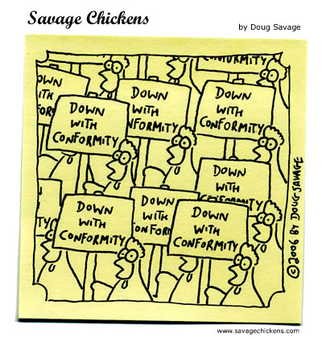

So 1.7 examine individualism as a key value of ideology (values of liberalism: individual rights and freedoms, self-interest, competition, economic freedom, rule of law, private property)

- Vocabulary: Liberalism
Find or create a visual image (e.g. cartoon, picture, drawing etc.) to represent the term | Book definition: | Personal Definition (put it in your own words)
Apply the term in a sentence (in context) | What is it not? (opposite terms) | Synonyms (similar terms)

- Vocabulary: Political Expressions of Individualism
Find or create a visual image (e.g. cartoon, picture, drawing etc.) to represent the term | Book definition: | Personal Definition (put it in your own words)
Apply the term in a sentence (in context) | What is it not? (opposite terms) | Synonyms (similar terms)
- Vocabulary: Economic Expressions of Individualism
Find or create a visual image (e.g. cartoon, picture, drawing etc.) to represent the term | Book definition: | Personal Definition (put it in your own words)
Apply the term in a sentence (in context) | What is it not? (opposite terms) | Synonyms (similar terms)

- Vocabulary: Social Expressions of Individualism
Find or create a visual image (e.g. cartoon, picture, drawing etc.) to represent the term | Book definition: | Personal Definition (put it in your own words)
Apply the term in a sentence (in context) | What is it not? (opposite terms) | Synonyms (similar terms)
- Vocabulary: Mercantilism
Find or create a visual image (e.g. cartoon, picture, drawing etc.) to represent the term | Book definition: | Personal Definition (put it in your own words)
Apply the term in a sentence (in context) | What is it not? (opposite terms) | Synonyms (similar terms)

- Vocabulary: Rule of Law
Find or create a visual image (e.g. cartoon, picture, drawing etc.) to represent the term | Book definition: | Personal Definition (put it in your own words)
Apply the term in a sentence (in context) | What is it not? (opposite terms) | Synonyms (similar terms)
- Vocabulary: Social Contract
Find or create a visual image (e.g. cartoon, picture, drawing etc.) to represent the term | Book definition: | Personal Definition (put it in your own words)
Apply the term in a sentence (in context) | What is it not? (opposite terms) | Synonyms (similar terms)

- Vocabulary: Supply and Demand
Find or create a visual image (e.g. cartoon, picture, drawing etc.) to represent the term | Book definition: | Personal Definition (put it in your own words)
Apply the term in a sentence (in context) | What is it not? (opposite terms) | Synonyms (similar terms)
- Vocabulary: Laissez-Faire
Find or create a visual image (e.g. cartoon, picture, drawing etc.) to represent the term | Book definition: | Personal Definition (put it in your own words)
Apply the term in a sentence (in context) | What is it not? (opposite terms) | Synonyms (similar terms)

10. Vocabulary: Self-interest
Find or create a visual image (e.g. cartoon, picture, drawing etc.) to represent the term | Book definition: | Personal Definition (put it in your own words)
Apply the term in a sentence (in context) | What is it not? (opposite terms) | Synonyms (similar terms)
Section B: Political Expressions of Individualism
Read pages 48-53 in your textbook and answer the following questions.
1. Describe the influences of the following events on the development of Liberalism
 | The American War of Independence, 1776 | The French Revolution, 1789 | The Magna Carta, 1215
Describe the Conflict
Influence on Individual Rights
How did these events change the Social Contract or Rule of Law

2. a. Describe what is meant by “reasonable limits placed on individual rights” under liberalism and give an example.

b. J.S. Mill famously wrote in his book On Liberty, “My right to swing my arm ends at my neighbour’s nose.” Explain what Mill is saying about the need to restrict individual rights.

3. a. Describe how the right to vote has been limited in liberal democracies over time.

b. Do you believe that these were “reasonable limits?”

c. What limits are placed on the right to vote in Canada today? Are they “reasonable” in your view?
4. a. What is Freedom of Expression?

b. Describe the limitations placed on Freedom of Expression using each of the following cases as examples:
Keegstra Case

Halstead Case

Ramsden Case

5. How is freedom of speech and the press handled in China?

6. Read the Summary on page 53 and copy the most important sentence in your view.

Section C: Economic Expressions of Individualism
1. Read page 54 and describe the major differences between Mercantilism and a Free Market Economy in the chart below:
Mercantilism | Free Market

2. Summarize or define the following people/terms:
Adam Smith p. 55

Economic Freedom p. 55

Competition p. 56-57

Private Property p. 57

Section D: Social Expressions of Individualism
Read pages 59-63 in your textbook and answer the following questions.
1. In what ways do modern liberals differ from early liberals?
Early Liberals | Modern Liberals

2. Explain why public education and public health care is important to modern liberals.

3. What is the link between Free Market Principles and Voucher systems for education?

4. Read the Summary on page 63 and copy the two most important sentences in your view.

Cartoon Analysis
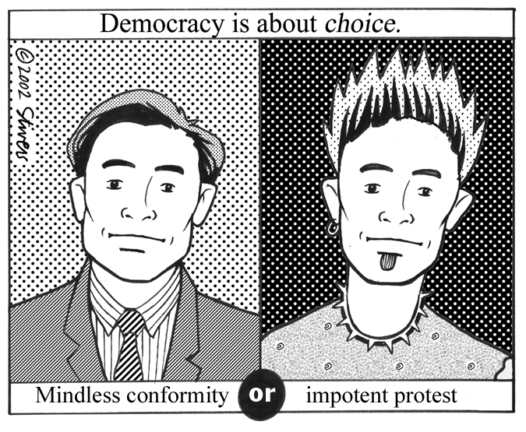
Explicit:

Implicit:

Perspective:

Principles of Collectivism
Principles of collectivism are the foundation of ideologies such as communism and socialism.
Over time most liberal democracies have evolved to incorporate aspects of collectivism into their political, economic, and social systems.
  - ______________________
  - ___________________
  - ____________________
  - _______________________
  - ______________________
  - _________________________________
  - _____________________
Economic Equality
- Economic equality can mean:
  - People with larger income pay ____________ taxes
  - All people should earn _________ pay for similar work
  - There should be a ______________ annual income (GAI)
  - All people should ____________ in the wealth of the country or world
  - People should own the means of production collectively
  - Everything should be ____________ (no private property)
Co-operation
  - Co-operation is the means through which members of a group or a collective work together to achieve their ______________ goals.
  - Some co-ops exist in Canada today

Public Property
- Public property is anything-land, buildings, vehicles, ideas
- They are maintained with __________ money/___________ and can be used by all members
Collective Interest
- Collective interest refers to the set of interests that members of a group have in common.
- While individual members may have individual interests, these interests are often better addressed by making them a common set of interests that the group can address together
- Labour ______________ are an example of common interests as they fight for better pay and working conditions.
Collective Responsibility
- Collective responsibility means holding the whole group ___________ for the actions of individuals (or individual groups) within the group.
- E.g.-“...underage drinking cannot be successfully addressed by focusing on youth alone. Youth drink within the context of a society in which alcohol use is normative behaviour and images about alcohol are pervasive.”
- In totalitarian states such as N. Korea, if one member of a family opposes the state in some way an entire family can be punished to send the message that that behaviour is not tolerated
Adherence to Collective Norms
- Groups usually impose norms or ______________ on their members as a condition of membership in the group
- Fraternities, political parties, faith groups, trade unions, etc, are all examples.

Are Collectivism and Individualism Incompatible?
When speaking of individualism and collectivism, people sometimes try to suggest that the two viewpoints are incompatible.
- While there are times that they are at odds, there are often aspects that ____________ each other.
- Sometimes individualism and collectivism work together for the _________ ________ of society.
- Americans are well known for their emphasis on the principle of individualism
- Even so, the majority of North Americans believe that government should provide _______ to those who need it, and idea that is essentially collectivist
Attitudes about Individualism and Collectivism

- Social capital is the strength of social relationships between individuals
- Some researchers have claimed that increased individualism in a society leads to an increased sense of commitment to the collective
- Indications lead us to believe that individualism and collectivism are not opposing concepts
- Individualism and Collectivism Co-Exist through:
- Entrepreneurialism - people pursue success individually but successful businesses do things beneficial to the collective like provide jobs or do positive things
- Social Programs - A country like Canada can be individualistic but also has social programs (health care, welfare, etc) that provide for all
- NGOs - these are created with specific goals in mind to benefit the community but are also privately created and funded
Collectivism
RI#1-Chapter 3 – Exploring Collectivism

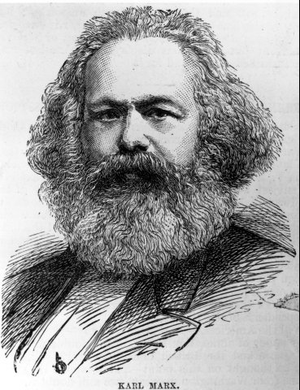

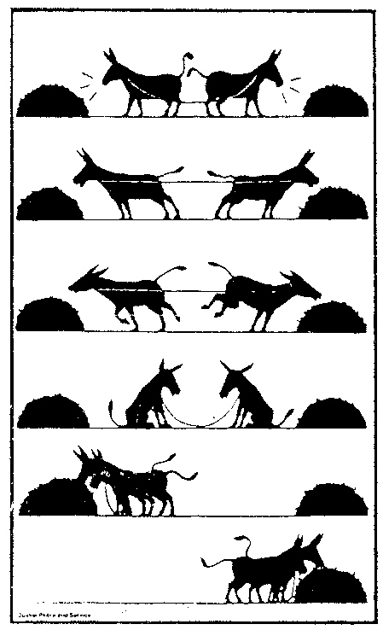

Key Concepts Developed in this Module
Key Concepts Definition Examples

Interdependence

Common Good

Economic Equality

Political Expressions
of Collectivism

Economic Expressions
of Collectivism

Social Expressions
of Collectivism

Section A: Early Collectivist Ideas

Read pages 68-70 and answer the following questions.

- Explain why the Employment Insurance program in Canada is an example of collectivism.

2. Think of two other examples in Canada where Canadians work together to ensure the Common Good. Describe each below.

3. In what way is collectivism an important part of indigenous culture?

4. Read the Summary on page 70 and copy the two most important sentences in your view.

Section B: Political Expressions of Collectivism
Read pages 71-77 and answer the following questions.

1. Complete the following chart.

Philosopher | Ideas about Collectivism
Thomas Hobbes
Jean-Jacques Rousseau
Karl Marx

2. Complete the following chart.

Political Expression | Definition | Example
Collective Interest
Collective Responsibility
3. In what way is collective responsibility an important component of Aboriginal Communities?

4. Complete the following chart comparing the three examples of collective responsibility
 | Sentencing Circles | Restorative Justice | North Korean Prison Camps
Compare and Contrast
Your Opinion

5. Read the Summary on page 77 and copy the two most important sentences in your view.

Section C: Economic Expressions of Collectivism
Read pages 78-85 and answer the following questions.

1. What are three influences the Industrial Revolution had on European society?

2. How did Karl Marx respond to these changes in society?

3. In Canada, what are some of the ways that government helps to see that there is “sharing of the wealth?”

4. Using the cartoon on page 81, what does the cartoon say about economic equality in the United States?

5. Complete the following chart.

Arguments for Public Property Arguments for Private Property

6. Describe what is meant by a Crown Corporation. In what ways are they an example of collective or public ownership?

7. Moving from a system of Public Ownership to Private Ownership is called ________________ .
The opposite, where you move from __________________ to ___________________ is called Nationalization

8. What is a cooperative?

5. Read the Summary on page 85 and copy the two most important sentences in your view.

6. Consider the following cartoons. What do they each mean in light of what you know about collectivism? What do you think about the issues?

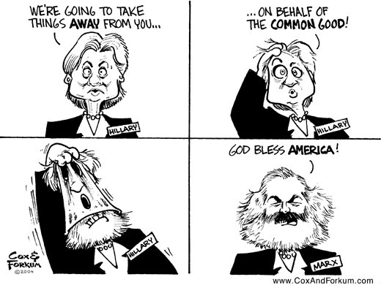
* Hillary Clinton is Secretary of State under President Obama.
Section D: Social Expressions of Collectivism
Read pages 86-89 and answer the following questions.

1. Complete the following chart
 | Description | Example
Co-operation
Collective Responsibility
Adherence to Collective Norms

2. Describe three Collective Norms of Tofield School. Make a list of formal and informal norms and explain the reason behind them.
Norm | Reason for the Norm
Section E: Health Care: Public, Private, or Both Assignment
Read page 90 and complete questions 1 to 6 in the space below.

Individualism and Collectivism Booklet
Evaluation = Accuracy and Perceptiveness

Teacher Marking Rubric for this Module

5 | 10 | 15 | 20 | 25
- Booklet is significantly incomplete or wildly inaccurate  - No significant corrections have been made | - Booklet is partially incomplete or inaccurate  - Few significant corrections have been made or the booklet is only corrections  - Unclear insight | - Booklet is partially complete and generally accurate  - Appropriate corrections have been made  - Predictable insights | - Booklet is complete and accurate  - Appropriate corrections have been made  - Thoughtful insights | - Booklet is thorough and accurate  - Appropriate corrections have been made  - Perceptive insights

