Related Issue #2
Written Assignment 1: Source Analysis
Social 10-1

Suggested time: 30-45 minutes

Examine all sources to assist your writing of the Assignment on page 2.

Source I

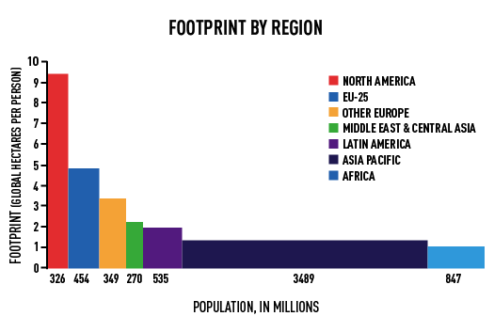

Source II

Source III
Source III

Assignment 1

What perspective(s) do each of the three sources present with regards to identity and globalization and what relationship(s) exists between the sources?

Examine each source. Use your knowledge and understandings of social studies and the information in the sources to write a response in paragraph form in which you:

Interpret each source to identify and explain the ideological perspective(s)
and their links to the ideological principles of collectivism and individualism

Identify and explain one or more of the relationships that are reflected between the sources.

Suggestions for Writing

- Respond in paragraph from organized in such a way as to effectively address both of the assigned tasks.

- Proofread and edit your response.

