Fake News Checklist
Note that this is not 100% foolproof — use the result as guidance. You always need to decide for yourself.
Observation | Evidence
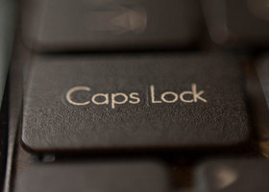
The Headline uses ALL CAPS
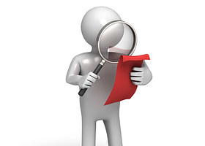
The headline makes a claim or statement that is NOT backed up by any of the information in the story itself
The author is not listed, or they use a pseudonym
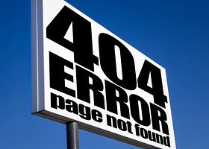
The site does not have an About page, or the page doesn’t clearly say who is behind it
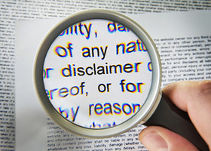
You click on the About or Disclaimer page and it says ‘fantasy news’, ‘satire’, or ‘blog’
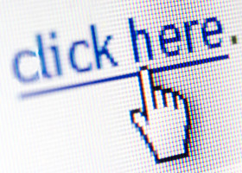
The story doesn’t have any links.
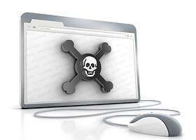
The story does have links but they don’t go to credible sites or sources you are familiar with.
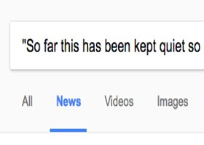
There are no stories about this from credible sites
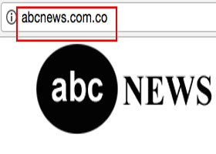
The site pretends to be a legitimate news site like ABC.com BUT is instead at @ ABC.com.co
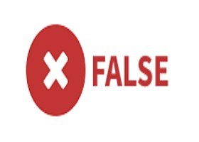
You google the URL or story at Snopes, Politifact, Wikipedia, or other trusted site.

Emotional impact of Fake News
Did the fake news/meme make you angry? Why?

Did the fake news/meme make you sad? Why?

Conclusion
Was the story true, somewhat true, or false? Circle ONE and support your decision.

Bonus
If somewhat true or false – what is the truth?

