Declaration of the Occupation of New York City
http://www.nationofchange.org/declaration-occupation-new-york-city-1317784408
This document was accepted by the NYC General Assembly on September 29, 2011, with minor updates made on October 1, 2011. It is the first official, collective statement of the protesters in Zuccotti Park.
As we gather together in solidarity to express a feeling of mass injustice, we must not lose sight of what brought us together. We write so that all people who feel wronged by the corporate forces of the world can know that we are your allies.
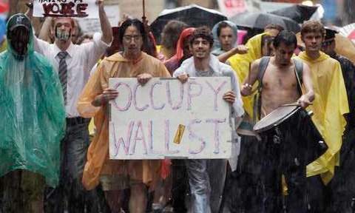
As one people, united, we acknowledge the reality: that the future of the human race requires the cooperation of its members; that our system must protect our rights, and upon corruption of that system, it is up to the individuals to protect their own rights, and those of their neighbors; that a democratic government derives its just power from the people, but corporations do not seek consent to extract wealth from the people and the Earth; and that no true democracy is attainable when the process is determined by economic power. We come to you at a time when corporations, which place profit over people, self-interest over justice, and oppression over equality, run our governments. We have peaceably assembled here, as is our right, to let these facts be known.
- They have taken our houses through an illegal foreclosure process, despite not having the original mortgage.
- They have taken bailouts from taxpayers with impunity, and continue to give Executives exorbitant bonuses.
- They have perpetuated inequality and discrimination in the workplace based on age, the color of one's skin, sex, gender identity and sexual orientation.
- They have poisoned the food supply through negligence, and undermined the farming system through monopolization.
- They have profited off of the torture, confinement, and cruel treatment of countless animals, and actively hide these practices.
- They have continuously sought to strip employees of the right to negotiate for better pay and safer working conditions.
- They have held students hostage with tens of thousands of dollars of debt on education, which is itself a human right.
- They have consistently outsourced labor and used that outsourcing as leverage to cut workers’ healthcare and pay.
- They have influenced the courts to achieve the same rights as people, with none of the culpability or responsibility.
- They have spent millions of dollars on legal teams that look for ways to get them out of contracts in regards to health insurance.
- They have sold our privacy as a commodity.
- They have used the military and police force to prevent freedom of the press.
- They have deliberately declined to recall faulty products endangering lives in pursuit of profit.
- They determine economic policy, despite the catastrophic failures their policies have produced and continue to produce.
- They have donated large sums of money to politicians, who are responsible for regulating them.
- They continue to block alternate forms of energy to keep us dependent on oil.
- They continue to block generic forms of medicine that could save people’s lives or provide relief in order to protect investments that have already turned a substantial profit.
- They have purposely covered up oil spills, accidents, faulty bookkeeping, and inactive ingredients in pursuit of profit.
- They purposefully keep people misinformed and fearful through their control of the media.
- They have accepted private contracts to murder prisoners even when presented with serious doubts about their guilt.
- They have perpetuated colonialism at home and abroad.
- They have participated in the torture and murder of innocent civilians overseas.
- They continue to create weapons of mass destruction in order to receive government contracts.*
To the people of the world,
We, the New York City General Assembly occupying Wall Street in Liberty Square, urge you to assert your power.
Exercise your right to peaceably assemble; occupy public space; create a process to address the problems we face, and generate solutions accessible to everyone.
To all communities that take action and form groups in the spirit of direct democracy, we offer support, documentation, and all of the resources at our disposal.
Join us and make your voices heard!

