20th Century rejections of liberalism
Chapter 5
Bloody Sunday
- January _________ workers in Russia marched to present a petition to the ________ asking for recognition of basic __________ rights such as freedom of speech, press, religion, etc.
- They also asked for a state-sponsored ___________ system, better working conditions, fairer _________, an 8 hour workday, etc.
- Hundreds were gunned down.
- Russians were outraged and grew more ________________. This eventually led to the ___________ Revolution in 1917.
The Russian Revolution
- The Russian Revolution was a reaction to the _______________ of the authoritarian czarist system and uncontrolled free-market capitalism which exploited the proletariat (____________).
- The Bolsheviks (_______________), under Vladamir Lenin, sought to destroy this _________-based system.
- We’ve already looked at responses to classical liberalism (Classical conservatism, Marxism, socialism, and welfare capitalism).
- Now we will look at ideologies that completely rejected liberalism in favour of totalitarian systems of government such as the Soviet Union and Nazi Germany.
Why did totalitarianism emerge?
- Communism and Fascism were the two most influential ideologies to _________ liberalism and both used totalitarian forms of government.
- Totalitarianism means complete control of the government over the public and private lives of its citizens.
“Everything within the state, nothing outside the state, nothing against the state.”
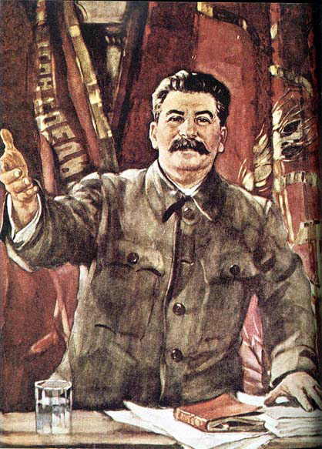
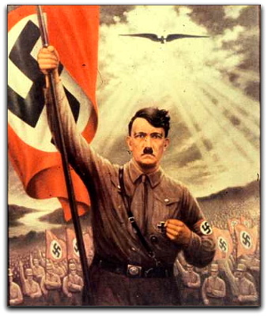
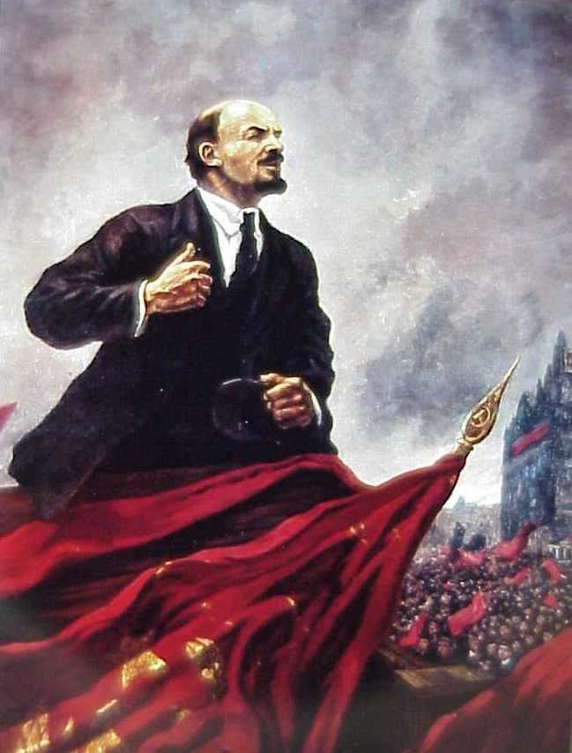
-Benito Mussolini

The nature of totalitarian regimes
- Totalitarian regimes are responding to what they see as dangerous and destabilizing changes. They consider the existing society in need of a complete transformation.
- These transformations may be...
radical | reactionary
As in the _________  The change desired is a move toward the far ________ side of the economic spectrum and a complete ______________ of political and economic traditions of the past | As in Nazi ____________  The change desired is a move toward an idealized past and an ______________ of economic inequality (accepting the belief that some people are naturally ___________ than others.)

- Like most ideologies, totalitarian regimes provide an account of the past, and explanation of the present, and a _______________ for the future. However, the extensive use of propaganda, coercive power, and communications technologies ensure the totalitarian governments maintain strict ______________over their citizens. This can include:
- Extensive local, regional, and national organization
- Youth, professional, cultural, and athletic groups (often forced participation)
- A secret ___________ using terror
- __________________ through education
- The censorship of the _________
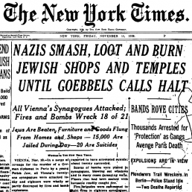
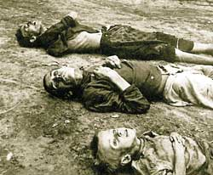
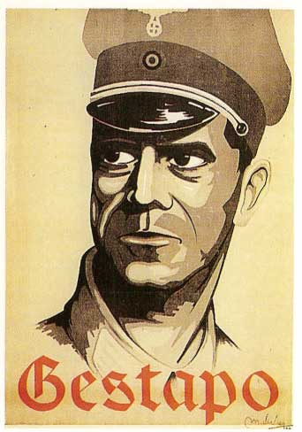
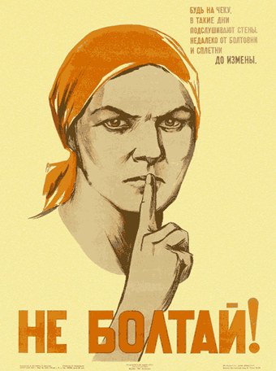
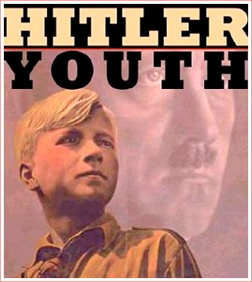
- Redirecting popular discontent (using _______________)

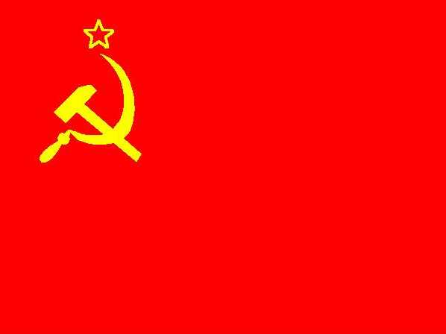
The rise of totalitarianism in Russia
- More then 80% of Russians were ______________; some of them were __________ (low income farmers who worked and were bound to the land of wealthy land-owners)
- Czar _______________ II announced the emancipation of the serfs in 1861 but the government was slow to implement the changes.
- Thus the reforms did little to satisfy Russian citizens
- From the 1860s to the early 1900s Russia underwent massive change
- Classical ____________economic policies led to rapid ______________________ but Russia still lagged behind the rest of Europe
- Russia also remained _______________ as the monarchy did not want to relinquish power
- In 1881 the Czar was assassinated and Czar Alexander III took power. He _____________ stricter political control; he exiled and persecuted dissidents using a secret police force.
Lenin and the rise of communism
- Czar’s government was ______________ and authoritarian
- __________ shortages were common
- The secret police were ____________
- Vladamir __________ (1870-1924) appealed to the struggling workers
- A revolution broke out in 1905 and although it was _______________, the Czar was forced to allow some reforms such as basic human rights, universal ______________, and the creation of an elected Legislative Assembly called the Duma
- These _____________ were not enough to satisfy the people, especially since the Czar _____________ the powers of the Duma before its first session
- The Fist World War broke out in 1914 which _________________ the problems in Russia
- In February 1917 ________________ developed into an outright revolution.
- Lenin’s communist _________________ took over the machinery of the government in an organized attack in ______________ 1917
“Land, Peace, and bread”
- Lenin and the Bolsheviks believed that ____________ revolution was the only way to overthrow the government and ___________ further development of ________________ in Russia
- However taking power was easier than staying in power; a __________ war erupted and lasted for 5 years.
- By 1922 the war was over and _______________ was established
- By 1924 Russia became the Union of Soviet Socialist Republics (USSR or Soviet Union), a ________________ rule by the Communist Party

The rise of totalitarianism in Germany
Aftermath of the first world war
- Immediately after the First World War in 1919, Germany became a _____________ with a modern, _____________ democratic political structure.
- This became known as the ______________ Republic
The treaty of Versailles
- German army of no more than 100 000 men and no tanks
- Reduce German navy, no __________________
- No German _________ force
- Alsace-Lorraine returned to ____________
- Germany loses all it’s colonies
- Rhineland became _________________
- _______________ (union) with Austria forbidden
- Germany forced to recognize ______________ and Czechoslovakia
- Germany had to sign the War __________ Clause (Article ________) which placed __________ on them
- A Reparations Commission decided Germany should pay $________billion US, they eventually paid $713 million US.
- Even though Germany had __________ choice in signing the treaty, much of the German population ____________ the government for the humiliation and economic hardship the treaty was cause for years to come.
- This ______________would undermine German confidence in their ____________ democratic government
- Furthermore, many Germans associated liberalism with the countries that defeated them in ___________

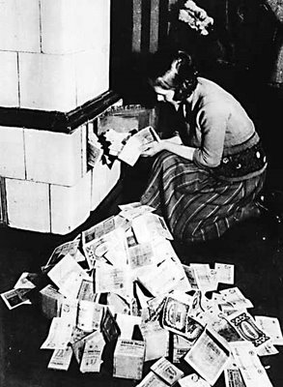
Economic turmoil
- After WW1 the German economy was in __________
- Germany had trouble with the reparation payments and
  - massive ____________saw savings
  - being wiped out
- Just when the economy started to improve the stock market crash of __________ and the Great Depression plunged the country into economic ______________once again.

A legacy of authoritarian rule in Germany
- Since the creation of the German Empire in 1871 the government was _______________ in many ways
- The Kaiser and the Chancellor held power and created a welfare state with health, accident, old-age, and disability insurance.
- Hence, many Germans saw authoritarian ayatem as benevolent.
Nationalism, militarism, and law & order
- When the Weimar Republic failed to provide Germans with any hope in hard times they looked back to _______________ rule
- Hitler capitalized on their fears
- Adolf Hitler’s Nazi party:
  - promoted absolute ________________, which called for the unification of all German-speakers
  - Used paramilitary organizations to stifle _____________ and to terrorize the opposition
  - Centralized decision making in a single leader to whom everyone owed loyalty
  - The Nazis’ advocacy of law and order ______________ to many Germans who were tired of years of ______________.
- Read the GET TO THE SOURCE section on page 176 of your text entitled The Program of the Nazi Party and answer questions 1-3 at the bottom of the page
Theories of racial superiority
- Nazi ideology included a ____________ theory that claimed that Germans formed a superior, “____________ race”
- They also used __________ as a ______________; they claimed that the Jews were the cause of many of Germany’s _____________
- Anti-_____________was not unique to Germany, many Christians blamed the Jews for the crucifixion of Jesus
- You must be familiar with forms and purposes of propaganda. If you are unfamiliar with propaganda read page 178.
- Living with communism and nazism
How did ideologies that rejected liberalism affect citizens?
- Any _____________that came out of these two ideologies were outweighed by the devastating __________ to many of the people living in those countries.
- While some citizens benefited, many others suffered or died.
Is it reasonable to suggest that the rejection of liberalism can be dangerous for citizens?
Communism in the Soviet Union
- Marx and __________ had developed theories of communism with Western European society in mind.
- Lenin believed ____________ had to be carried out differently in Russia
- This came to be called “war ________________” but the conversion could not take place as quickly as first hoped
- In 1921, Lenin introduced the New ____________ Policy (NEP) which brought back some aspects of capitalism temporarily to _______________the economy
- The state retained ____________of banking, large industry, transportation, etc
Stalin: 5 year plans & collectivization
- Lenin death in 1924 led to a 4 year
  - struggle for power until Joseph ___________
  - took power
- Stalin continued with making Russia more communist by _______________ economic planning and implementing _____ year plans (industrial production increase by ______per year)
- The government implemented collectivization-all land was taken away from ____________ owners and combined into large, collectively worked farms
- Along with collectivization came the _______________ of the kulaks-a class of prosperous _________-owning peasants
- Kulaks who did not give up their property were ____________ and deported, or in some cases executed; they became the scapegoats of collectivization
- Few peasants were satisfied with the changes, some destroyed crops and farm equipment, and slaughtered their animals rather than give them up to the ________
- These disruptions to agricultural production led to food shortages such as the _____________ in Ukraine
Stalin eliminates political opposition
- Some became _______________ with Stalin’s leadership
- He responded with a period of political ______________ known as the Great _________ (1936-1938)
- Political opponents were executed or sent into exile, it included most of the highest ranking officers of the Red Army
- Almost 2 million were arrested, half of them executed; the rest sent to forced labour camps in Siberia. These camps were known as the __________
Consolidating power
- In November 1932, the Nazi party held 1/3 of the seats in the _______________. By 1933 Hitler was named _______________. Capitalizing on the situation he quickly turned Germany into a ______________ state.
- A fire in the Reichstag was used by Hitler to spread fear of a communist takeover. Although it is believed the Nazis actually _____________ the fire he used the incident to ____________ his power
Hitler passed the Reichstag Fire Decree and Enabling Act in 1933 which made it possible to:
- ____________personal ____________, freedom of opinion, freedom of the press, and freedom of organization and assembly
- Eliminate the ___________ of mail, telegrams, and phone conversations
- Eliminate the need for ___________ to conduct searches
- Pass legislation through the office of the Chancellor without the approval of the ____________
- _________ all political parties except the Nazi party
- Germany has become a ___________ by 1933
- The Nazis __________ Germany of opposition to them
- When President Hindenburg died August 19, 1934, Hitler declared himself _____________
- While individual rights suffered, the economy ______________: 6 million Germans were unemployed in 1932, in 1936 only 1 million were unemployed
- Foreign imports were restricted to promote German products designed to achieve ___________ (self-sufficiency and independence from other nations)
Nazi Eugenics
- Nazi ideology ______________ the superiority of the Aryan race and eugenics-controlling human reproduction so that desirable genetic traits are encouraged and undesirable traits are _____________
- 9-11 million people, including 6 million Jews, who were considered Untermenschen (________________) and were killed by the Nazis
Read the GET TO THE SOURCE section at the top of page 190 and we’ll discuss it
- The strict enforcement of law and order gave people a sense of ____________
- Transportation improved
- ____________ and propaganda brought hope and confidence
Hitler “is my mother and my father. He keeps me safe from all harm”
Women and youth
- Nazi Germany was a _______________ dominated society. Women were primarily to stay at home and raise children
- Couples were rewarded for having children (pg 192)
- The Nazis also saw the importance of __________ people as the future of the Reich
- ____________ were active participants in Nazism and were even encouraged to report __________-Nazi acts even by their parents

