Chapter 12
Shaping a Unique worldview
Student Name:

VOCABULARY
Izanagi

Izanami

Kami

Projection

Distortion

Isolated

Archipelago

Ritual

Ainu

Kamuy

Matsuri

Tsunami

Stoic

Arable

Monsoon

Gohan

Homogeneous

Assimilation

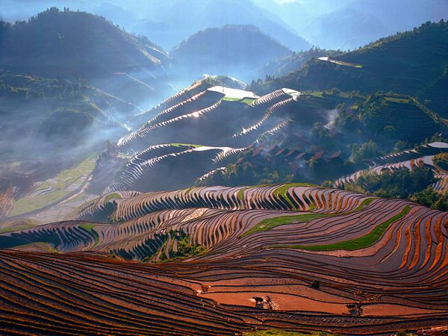
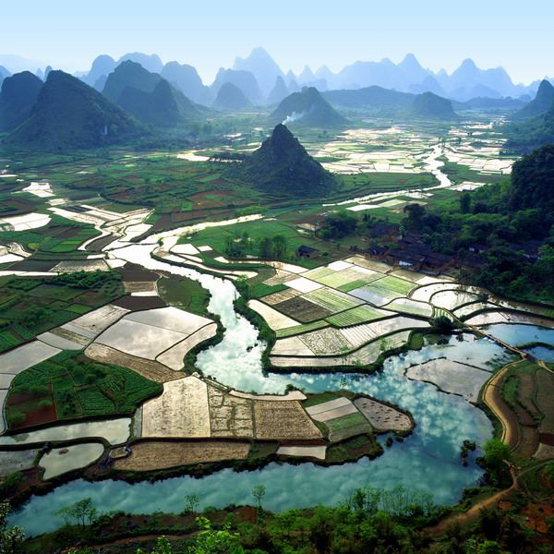
PHOTO ANALYSIS
- What conclusions can you come to about Japan when you look at the above two pictures:

A SELF-SUFFICIENT COUNTRY
A Japanese proverb states: “Eat rice before battle and you will be victorious.” Rice symbolizes self-sufficiency for the Japanese. It is also an excellent example of the importance of nature and geography to Japan’s worldview. This section will highlight a key element of Japanese culture and worldview – rice.
The sea also provides an excellent source of employment and nourishment for the Japanese. Japan’s fishing fleet is one of the largest in the world, taking 15% of the worldwide catch.
RESOURCES AND CLIMATE
According to your text, Japan had little trade compared to the countries of Renaissance Europe. After reading page 174, “Resources and Climate,” complete the table by listing the points made regarding Japan survival and prosperity. The first point has been completed for you!

Resources and Climate
- Japan’s farmers and fishers provided sufficient food for the people.

Complete the web that follows by filling in the bubbles with points regarding Japan’s resources and climate as described on page 274.
Nature compensated for the limited amount of arable land by:

Japan’s Climate
Land:
Temperature:
Seasons:
Other:

RICE: THE SYMBOL OF A COUNTRY
- In short paragraph form, describe the necessary requirements to grow rice. How did farmers increase their productivity? (Figure 12-18)

- Besides being a main source of nutrition in Japan, rice also served a second purpose to the Japanese people. Describe this purpose and explain how it similar to Aztec society.

A HOMOGENOUS SOCIETY
- The people of Japan are known as a homogenous culture. In paragraph form, define homogeneous society and explain why Japan was able to have a unified, common society, although the people were often so far apart.

A DISTINCT PEOPLE
- Who were the Ainu people and how is their story comparable to that of the First Nations people of Canada? Explain!

