Blackout Poetry

“Every block of stone has a statue inside it, and it is the task of the sculptor to discover it.” --Michelangelo
Italian Renaissance artist Michelangelo believed that a statue was waiting in stone, and that a sculptor’s job was to chip away at what didn’t belong until the statue revealed itself. Maybe the same is true about poetry. If you look long enough at a sheet of words, you may be able to find rhythm, patterns, and brilliance. Your reward for your patience? Revealing the poem within. It was waiting for you to free it all along. This is called Blackout Poetry.
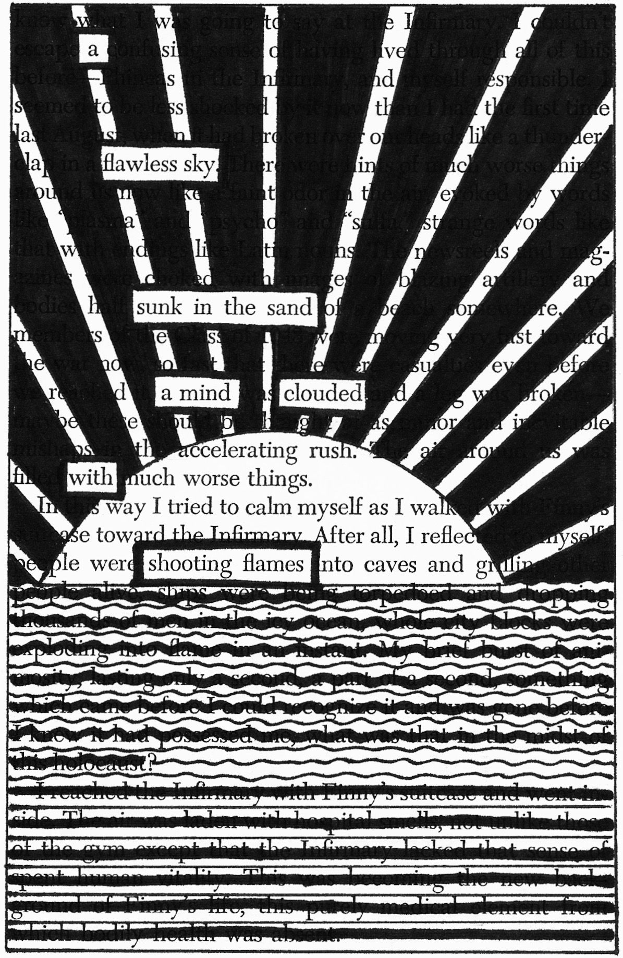
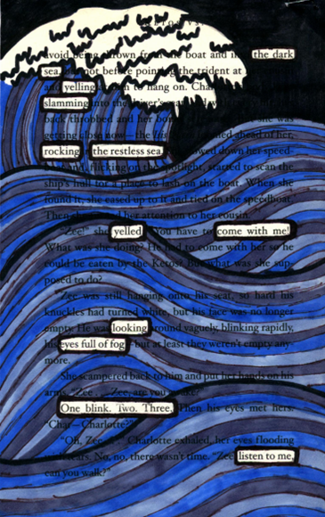
- STEP ONE: Grab a black pen or marker and find and print article online or a photocopy a page of a book, newspaper, or magazine.
- STEP TWO: Search the text for reoccurring words, phrases, and ideas that speak to you and the topic you want to write about. Remember to look within words too. Lightly underline these words.
- STEP THREE: Black out what doesn’t belong. Chisel away one word at a time until your poetic masterpiece reveals itself. Decorate or design the other areas of the page. The remaining poem should have a narrative arch - a brief story about characters in conflict.
- STEP FOUR: Give your poem a title.
- STEP FIVE: On the back of your poem rewrite the whole poem, write a header that says "About my Poem" and reflect on the writing process.
  - What is the conceit (controlling idea) of your poem?
  - Why did you pick the words you picked?
  - Why did you put line breaks where you did? (structure)
  - Add a few lines now that would improve the poem:
