And Even Now
Student Name Date:

Developing Mood & Descriptive Writing

In descriptive writing, mood is a piece's atmosphere, the overall feeling you experience as you read. A description of a beach on a sunny day may make you feel relaxed and peaceful, while an old house thrashed with trees during a thunderstorm might communicate fear. By using careful word choice and vivid imagery, you can fill your writing with clear description and emotion.

Diction
Creating mood begins with diction, the writer's selection of words. When developing atmosphere, writers especially consider the connotations, or emotional associations, of words. Descriptions can create a positive or negative mood depending on the words' connotation. For example, "The puffy clouds dotted the sky" creates a different mood than "Heavy, grey clouds loomed overhead." The difference comes down to the emotion each word conveys; "puffy" creates a playful mood, while the long vowels in "grey" and "loomed" suggest a foreboding feeling.

- In the poem find one example of the use of diction to create mood and write it below. How does the choice of these words affect the mood?

Tone
Tone, the emotional attitude of a piece, also plays a role in developing mood and description. Tone is different than mood because it focuses on the voice of the piece rather than the overall atmosphere. For example, "We lived in a rundown dump next to a ditch" uses the speaker's attitude to describe the situation; the words "rundown," "dump" and "ditch" all reveal bitterness and resentment toward the speaker's environment. This attitude also describes the speaker's environment and invokes a gloomy mood.

What is the emotional attitude of this piece (see Mood in Literature image)? List three words from the poem that contribute to this mood.

Setting
Mood is also important to descriptions of a story's setting. Seasons, time of day, location and weather all carry different emotional associations. For example, a story about a wedding can take on a different mood simply by changing the weather; a wedding on a bright sunny day can create a celebratory mood, while a ceremony that takes place as a thunderstorm rages can cause a foreboding atmosphere. As a result, descriptions of a setting's elements can have a huge impact on readers' reactions to the story.

- What is the setting of the poem and how does the setting affect the mood?

Imagery
Imagery is a descriptive device where writers create sensory details with words. Portraying the sights, smells and textures of the story's environment lets readers experience the story. They can see the bride's dress wilt as she emerges from the church into the rain, taste a bitter cherry or rotten apple or hear waves crashing during a storm at sea. Imagery can also create a story's mood; the wet wedding dress might communicate sadness, while a storm on the ocean can induce fear and danger. Careful use of diction can create powerful descriptive images that resonate with readers.

- Quote one descriptive image that helps you visualize the creepy mood of the poem. What makes it effective?

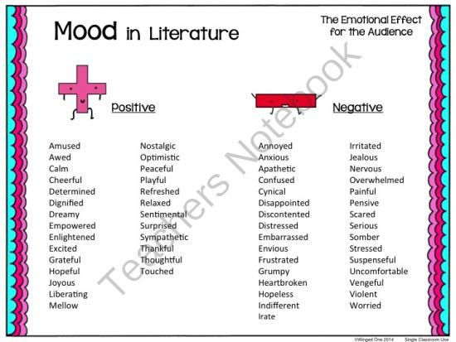
Response (CHOOSE ONE)
Option One: Create a three-panel illustration of this poem with one panel per stanza. Try to capture the mood of each stanza in your illustrations.

Option Two: Write a three stanza poem about your summer holidays. Try and use diction, tone, setting and imagery to create a powerful mood.

