Analyzing Images - Social 10
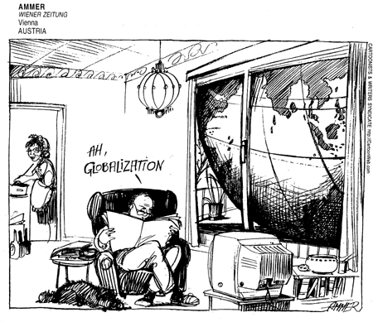
Step One - Explicit Messages (describe the image to a blind person – answer the W5 questions)

Step Two – Implicit Messages (what is the meaning of the image – how is it connected to our course - Globalization)

Step Three – Perspective (what is the artists opinion or position – how do they feel/what do they think about globalization?)

Step Four – Title (give the image a title – summary of main idea)

Step Five – Vocabulary or Course ideas (Identify vocabulary or course ideas that are present in the image)

