**Activity Two: Propaganda Techniques**

Propaganda techniques are communication approaches and methods used to spread ideas that further a cause – political, commercial, religious, or civil. They are used to manipulate the reason and emotion of the viewer, reader, or listener, to persuade him or her to believe in someone or something, to buy an item, or to practice particular behaviors.

1. Read the “Propaganda Techniques” article from Wikipedia.
2. View the selected video excerpts from “Triumph of the Will” and complete the **Triumph of the Will Propaganda Record Sheet**.
3. In your groups” Choose ONE of the following:
   1. Create your own propaganda message
   2. Research and select two examples of propaganda
4. Complete the Propaganda presentation check list. Create a presentation to share your findings as recorded on the (**Research Project Propaganda Record Sheet)**
5. Your presentation should contain the following elements:
   1. The created or researched examples of propaganda
   2. An explanation of the intent of the propagandist
   3. Identification of the techniques of propaganda that are used
   4. Discern the facts from interpretations in your propaganda (or present alternative views)

# **Propaganda techniques**

### From Wikipedia, the free encyclopedia

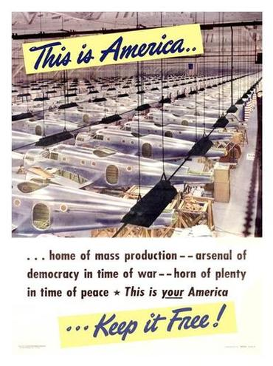Common media for transmitting propaganda messages include news reports, government reports, books, leaflets, movies, radio, television, and posters. In the case of radio and television, propaganda can exist on news, current-affairs or talk-show segments, as advertising or public-service announce "spots" or as long-running advertorials. Propaganda campaigns often follow a strategic transmission pattern to indoctrinate the target group. This may begin with a simple transmission such as a leaflet dropped from a plane or an advertisement. Generally these messages will contain directions on how to obtain more information, via a web site, hot line, radio program, et cetera (as it is seen also for selling purposes among other goals). The strategy intends to initiate the individual from information recipient to information seeker through reinforcement, and then from information seeker to opinion leader through indoctrination.

A number of techniques based in social psychological research are used to generate propaganda. Many of these same techniques can be found under logical fallacies, since propagandists use arguments that, while sometimes convincing, are not necessarily valid.

Some time has been spent analyzing the means by which propaganda messages are transmitted. That work is important but it is clear that information dissemination strategies only become propaganda strategies when coupled with *propagandistic messages*. Identifying these messages is a necessary prerequisite to study the methods by which those messages are spread. Below are a number of techniques for generating propaganda:

* **Ad hominem:** A Latin phrase which has come to mean attacking your opponent, as opposed to attacking their arguments.
* **Ad nauseam:** This argument approach uses tireless repetition of an idea. An idea, especially a simple slogan, that is repeated enough times, may begin to be taken as the truth. This approach works best when media sources are limited and controlled by the propagator.
* **Appeal to authority:** Appeals to authority cite prominent figures to support a position, idea, argument, or course of action.
* **Appeal to fear:** Appeals to fear seek to build support by instilling anxieties and panic in the general population, for example, Joseph Goebbels exploited Theodore Kaufman's *Germany Must Perish!* to claim that the Allies sought the extermination of the German people.
* **Appeal to prejudice:** Using loaded or emotive terms to attach value or moral goodness to believing the proposition. For example, the phrase: "Any hard-working taxpayer would have to agree that those who do not work, and who do not support the community do not deserve the community's support through social assistance."
* **Bandwagon:** Bandwagon and "inevitable-victory" appeals attempt to persuade the target audience to join in and take the course of action that "everyone else is taking."
* **Inevitable victory**: invites those not already on the bandwagon to join those already on the road to certain victory. Those already or at least partially on the bandwagon are reassured that staying aboard is their best course of action.
* **Join the crowd:** This technique reinforces people's natural desire to be on the winning side. This technique is used to convince the audience that a program is an expression of an irresistible mass movement and that it is in their best interest to join.
* **Black-and-White fallacy:** Presenting only two choices, with the product or idea being propagated as the better choice. (e.g., "You are either with us, or you are with the enemy")
* **[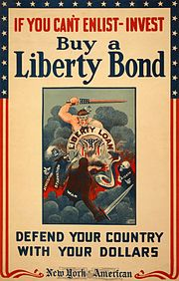](http://en.wikipedia.org/wiki/File:LibertyBond-WinsorMcCay.jpg)Beautiful people:** The type of propaganda that deals with famous people or depicts attractive, happy people. This makes other people think that if they buy a product or follow a certain ideology, they too will be happy or successful. (This is more used in advertising for products, instead of political reasons)
* **Big Lie:** The repeated articulation of a complex of events that justify subsequent action. The descriptions of these events have elements of truth, and the "big lie" generalizations merge and eventually supplant the public's accurate perception of the underlying events. After World War I the German Stab in the back explanation of the cause of their defeat became a justification for Nazi re-militarization and revanchist aggression.
* **Common man:** The "'*plain folks'*" or *"common man"* approach attempts to convince the audience that the propagandist's positions reflect the common sense of the people. It is designed to win the confidence of the audience by communicating in the common manner and style of the target audience. Propagandists use ordinary language and mannerisms (and clothe their message in face-to-face and audiovisual communications) in attempting to identify their point of view with that of the average person. For example, a propaganda leaflet may make an argument on a macroeconomic issue, such as unemployment insurance benefits, using everyday terms: "given that the country has little money during this recession, we should stop paying unemployment benefits to those who do not work, because that is like maxing out all your credit cards during a tight period, when you should be tightening your belt."
* **Demonizing the enemy:** Making individuals from the opposing nation, from a different ethnic group, or those who support the opposing viewpoint appear to be subhuman (e.g., the Vietnam War-era term "gooks" for National Front for the Liberation of South Vietnam aka Vietcong, (or 'VC') soldiers), worthless, or immoral, through suggestion or false accusations.
* **Direct order:** This technique hopes to simplify the decision making process by using images and words to tell the audience exactly what actions to take, eliminating any other possible choices. Authority figures can be used to give the order, overlapping it with the Appeal to authority technique, but not necessarily. The Uncle Sam "I want you" image is an example of this technique.
* **Euphoria:** The use of an event that generates euphoria or happiness, or using an appealing event to boost morale. Euphoria can be created by declaring a holiday, making luxury items available, or mounting a military parade with marching bands and patriotic messages.
* **Flag-waving:** An attempt to justify an action on the grounds that doing so will make one more patriotic, or in some way benefit a group, country, or idea. The feeling of patriotism which this technique attempts to inspire may not necessarily diminish or entirely omit one's capability for rational examination of the matter in question.[](http://en.wikipedia.org/wiki/File:SuomiNeito.png)
* **Oversimplification**: Favorable generalities are used to provide simple answers to complex social, political, economic, or military problems.
* **Name-calling:** Propagandists use the *name-calling technique* to incite fears and arouse prejudices in their hearers in the intent that the bad names will cause hearers to construct a negative opinion about a group or set of beliefs or ideas that the propagandist would wish hearers to denounce. The method is intended to provoke conclusions about a matter apart from impartial examinations of facts. Name-calling is thus a substitute for rational, fact-based arguments against the an idea or belief on its own merits.[[1]](http://en.wikipedia.org/wiki/Propaganda_techniques#cite_note-0)
* 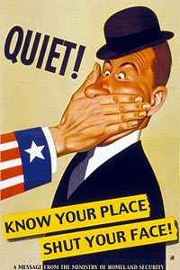**Red herring:** Presenting data or issues that, while compelling, are irrelevant to the argument at hand, and then claiming that it validates the argument.
* **Labeling:** A Euphemism is used when the propagandist attempts to increase the perceived quality, credibility, or creedence of a particular ideal. A Dysphemism is used when the intent of the propagandist is to discredit, diminish the perceived quality, or hurt the perceived righteousness of the Mark. By creating a 'label' or 'category' or 'faction' of a population, it is much easier to make an example of these larger bodies, because they can uplift or defame the Mark without actually incuring legal-defamation. Example: "Liberal" is a dysphamsim intended to diminish the perceived credibility of a particular Mark. By taking a displeasing argument presented by a Mark, the propagandist can quote that person, and then attack 'liberals' in an attempt to both (1) create a political battle-ax of unaccountable aggression and (2) diminish the quality of the Mark. If the propagandist uses the label on too-many perceivably credible individuals, muddying up the word can be done by broadcasting bad-examples of 'liberals' into the media. Labeling can be thought of as a sub-set of Guilt by association, another Logical Fallacy.
* **Repetition:** This type of propaganda deals with a jingle or word that is repeated over and over again, thus getting it stuck in someones head, so they can buy the product. The "Repetition" method has been described previously.
* **Scapegoating:** Assigning blame to an individual or group, thus alleviating feelings of guilt from responsible parties and/or distracting attention from the need to fix the problem for which blame is being assigned.
* 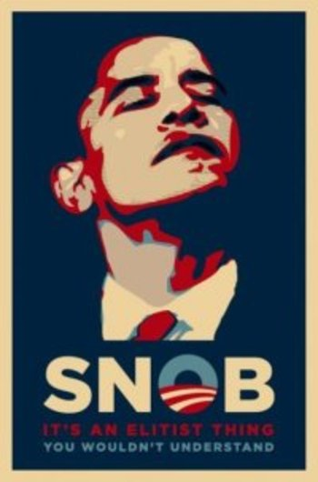**Slogans:** A slogan is a brief, striking phrase that may include labeling and stereotyping. Although slogans may be enlisted to support reasoned ideas, in practice they tend to act only as emotional appeals. Opponents of the US's invasion and occupation of Iraq use the slogan "blood for oil" to suggest that the invasion and its human losses was done to access Iraq's oil riches. On the other hand, "hawks" who argue that the US should continue to fight in Iraq use the slogan "cut and run" to suggest that it would be cowardly or weak to withdraw from Iraq. Similarly, the names of the military campaigns, such as "enduring freedom" or "just cause", may also be regarded to be slogans, devised to influence people.
* **Stereotyping or Name Calling or Labeling:** This technique attempts to arouse prejudices in an audience by labeling the object of the propaganda campaign as something the target audience fears, hates, loathes, or finds undesirable. For instance, reporting on a foreign country or social group may focus on the stereotypical traits that the reader expects, even though they are far from being representative of the whole country or group; such reporting often focuses on the anecdotal.
* **Testimonial:** Testimonials are quotations, in or out of context, especially cited to support or reject a given policy, action, program, or personality. The reputation or the role (expert, respected public figure, etc.) of the individual giving the statement is exploited. The testimonial places the official sanction of a respected person or authority on a propaganda message. This is done in an effort to cause the target audience to identify itself with the authority or to accept the authority's opinions and beliefs as its own. *See also, damaging quotation*
* **Virtue words:** These are words in the value system of the target audience which tend to produce a positive image when attached to a person or issue. Peace, happiness, security, wise leadership, freedom, "The Truth", etc. are virtue words. In countries such as the U.S. religiosity is seen as a virtue, making associations to this quality affectively beneficial. See ""Transfer"".